Operation Santa Claus/UBS NGO Leadership Programme
Innovation award challenge
Project Report

Project title:

Applicant:

Applicant’s Organization:

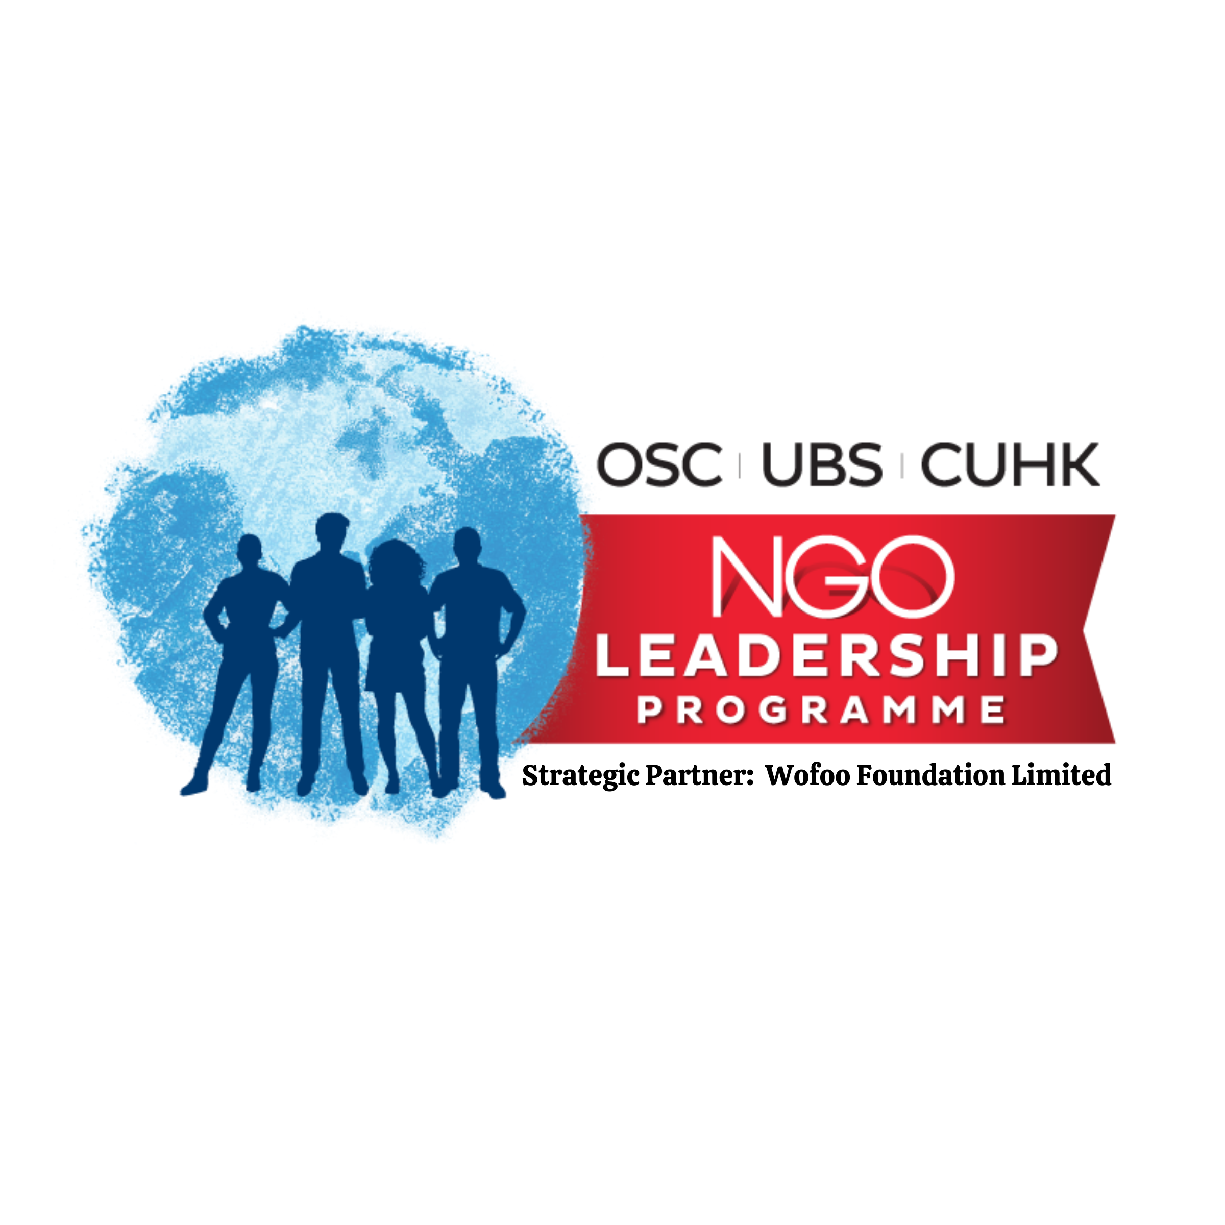

Strategic Partner: Wofoo Foundation Limited
Please create your own report with the following template. The project report should not exceed 600 words.

Project title:

Duration of Project:
☐ Ongoing; From ______________ (Month/ Year) to ______________ (Expected Month/ Year)
☐ Completed; From ______________ (Month/ Year) to ______________ (Month/ Year)

Service Needs identified during the Pandemic:

Target Group and Implementation Strategy:

Please describe the innovative features of the Project:

Please highlight the outcomes / preliminary outcomes of the Project:
e.g. Survey results, Staff Observation, User Feedback

